1. 測試內容:

測試L2 Interface Group Entry with type “INDIRECT”.

1. 測試環境架構:

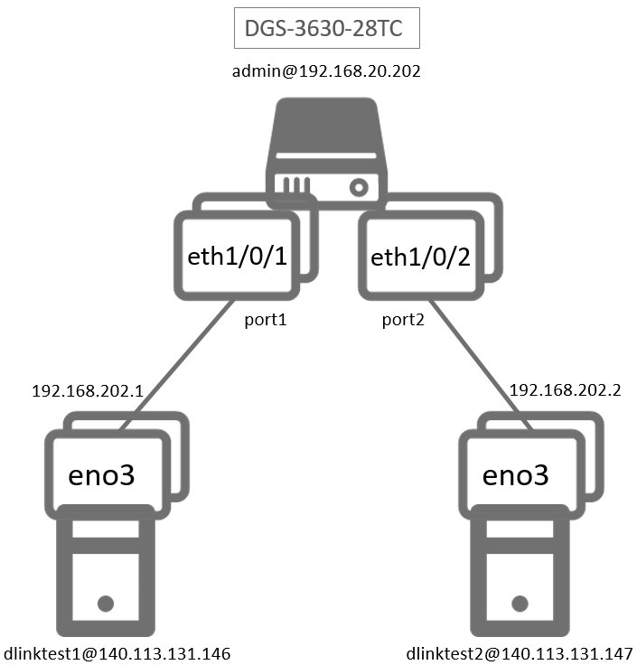

1. 測試環境組態

* SDN controller: ONOS 1.15.0
* Switch: DGS-3630
* Hosts:
* ubuntu 16.04.5 LTS
* dlinktest1(實體機)
  + - IP : 192.168.202.1
    - MAC : d0:94:66:5d:5e:08/64
    - Port : 1
* dlinktest2(實體機)
  + - IP : 192.168.202.2
    - MAC : d0:94:66:5c:45:20/64
    - Port : 2
* Apps:

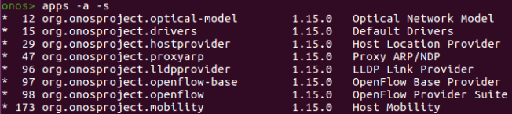

1. 使用之JSON文件

* Flow rule: (附檔: group_L2Interface_flow.json)

|  |
| --- |
| {  "flows":  [  {  "priority":100,  "timeout":0,  "isPermanent":true,  "deviceId":"of:000078321bdf4000",  "treatment":{  "instructions":[],  "deferred":[  {  "type":"GROUP",  "groupId":65538  }  ]  },  "selector":{  "criteria":[  {  "type":"IN_PORT",  "port":"1"  }  ]  }  },  {  "priority":101,  "timeout":0,  "isPermanent":true,  "deviceId":"of:000078321bdf4000",  "treatment":{  "instructions":[],  "deferred":[  {  "type":"GROUP",  "groupId":65537  }  ]  },  "selector":{  "criteria":[  {  "type":"IN_PORT",  "port":"2"  }  ]  }  }  ]  } |

* Group rule: (附檔: group_65537.json)

appCookie可以任意設定

groupId請依照<12bit-vlan><16bitPortId>的格式設定

|  |
| --- |
| {  "type":"INDIRECT",  "appCookie":"0x123abc",  "groupId":65537,  "buckets":[  {  "treatment":{  "instructions":[  {  "type":"OUTPUT",  "port":1  }  ]  }  }  ]  } |

* (附檔: group_65538.json)

|  |
| --- |
| {  "type":"INDIRECT",  "appCookie":"0x456def",  "groupId":65538,  "buckets":[  {  "treatment":{  "instructions":[  {  "type":"OUTPUT",  "port":2  }  ]  }  }  ]  } |

1. 測試步驟
2. ONOS GUI: Group/Flow View





1. Monitor: Using ping tool

* Let dlinktest1 ping dlinktest2

$ ping -c 3 -I eno2 192.168.202.2

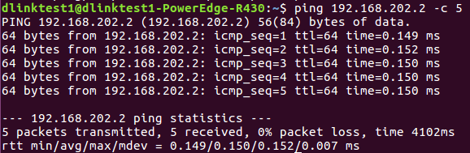

* dlinktest2 uses tcpdump to monitor

$ sudo tcpdump -ni eno3 icmp

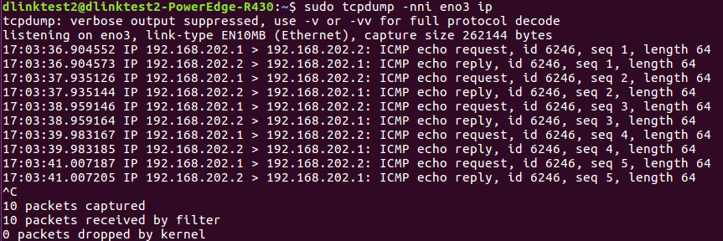

1. Monitor: Switch CLI

* Show group entries

Switch# show openflow group

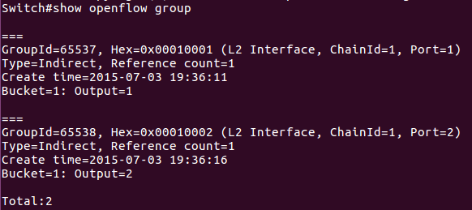

* Show flow entries

Switch# show openflow flows | include Group

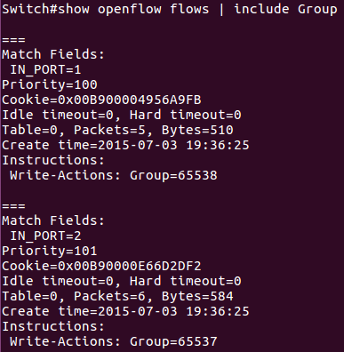

1. 測試結果

* the group entry was added successfully to the switch.
* the flow entry was added successfully to the switch.
* ONOS GUI cannot count Bytes/Packets of group entry.
* Switch can count Reference Count correctly.
* the data streams can be forwarded to correct port.